**Door security system**

B.Tech Project report

Submitted in partial fulfillment of the requirements for

**Door Security System**

**Submitted By**

Bannuru Veerendra (20191IST0193)

Yamini N (20191IST0173)

Sirimalli Shiva Krishna (20191IST0148)

Sneha M (20191IST0150)

Sai Meghana JS (20191IST0187)

Department of Computer Science and Engineering

School of Engineering

Under the Guidance of

**Prof. Riyazulla Rahman J**

Assistant Professor-G1

Department of Computer Science and Engineering

School of Engineering



PRESIDENCY UNIVERSITY, BENGALURU

2021-22

**Department of Computer Science & Engineering**

**Bengaluru**



**Certificate**

This is to certify that the project entitled “**Door Security System**” has been successfully completed by Mr Bannuru Veerendra, Ms Yamini N, Mr Sirimalli Shiva Krishna, Ms Sneha M, Ms Sai Meghana JS of 7th semester B Tech at **Presidency University. Bengaluru,** as the Internet Of Things project in partial fulfilment for the award of B tech Degree course conducted by the Presidency University. The Project Report presented here is the bonafide work of the student.

**Guide: Head of the Department**

Prof. Riyazulla Rahman J Dr. Kalaisaran

Assistant Professor-G1 Associate Dean (CSE)

**Group Members:**

|  |  |
| --- | --- |
| **ID** | **NAME** |
| 20191IST0193 | Bannuru Veerendra |
| 20191IST0173 | Yamini N |
| 20191IST0148 | Sirimalli Shiva Krishna |
| 20191IST0150 | Sneha M |
| 20191IST0187 | Sai Meghana JS |

**Acknowledgement**

While performing our project, we had to take the help and guidelines of some respected persons who deserve our greatest gratitude. The completion of this project gave us immense pleasure.

We are highly indebted to Dr. C.Kalaiarasan, Mr. Riyazulla Rahman J sir,for their guidance, constant supervision and for their support in completing our project.

We would like to express our gratitude to our parents for their kind co-operation and encouragement.

**ABSTRACT**

Our project presents a microcontroller based digital door lock security system using keypad which will provide complete security solution to lives and properties at homes, schools and offices.

The security system contains a 4X4 keypad input unit for entering the Personal Identification Number (PIN). It also contains a servo motor that serves as a switching for locking and unlocking the door and a programmed microcontroller that processes the input information and take appropriate action.

When a user enters a PIN into the security system installed at any entrance, the systemcaptures the PIN and compares it with the stored PINS for a match. If the captured PIN matches with any of the stored PINs, access granted and the door opens; otherwise, access denied and the door remains closed

**Table of Contents**

*Acknowledgement*

*Abstract*

1. Components Required 06
2. Features of Components Used 07
3. Pinout Diagram 11
4. Manual Connection of the Project 12
5. Code 13
6. Read Me 15
7. Conclusion 16

**COMPONENTS REQUIRED**

1. Arduino Uno
2. Key pad
3. Servo motor
4. Jumper wires

**FEATURE OF COMPONENTS USED**

1. **Arduino Board**

Arduino is a prototype platform (open-source) based on an easy-to-use hardware and software. It consists of a circuit board, which can be programed (referred to as a microcontroller) and a ready-made software called Arduino IDE (Integrated Development Environment), which is used to write and upload the computer code to the physical board.

Arduino provides a standard form factor that breaks the functions of the micro-controller into a more accessible package.

**Arduino Pin Out Diagram**

1. **Key pad**

The 4×4 matrix membrane keypad is most commonly used in projects. It follows a logical matrix where 16 keysare divided into 2 groups as ROW keys and COLUMN keys.. They can be connected using 8 pins from 1 to 8.

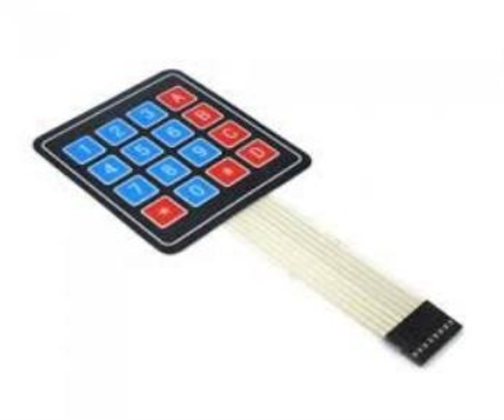

1. **Servo metor**

A servo motor is a self-contained electrical device, that rotate parts of a machine with high efficiency . The output shaft of this motor can be moved to a particular angle, position and velocity that a regular motor does not have.

1. **Jumper wires**

A jump wire (also known as jumper wire, or jumper) is an electrical wire, or group of them in a cable, with a connector or pin at each end, which is normally used to interconnect the components of a breadboard or other prototype or test circuit, internally or with other

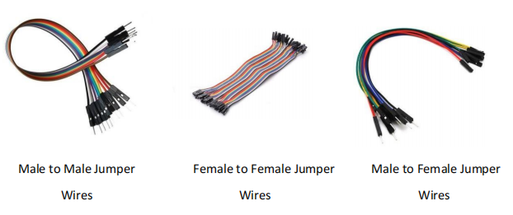

**PINOUT DIAGRAM**

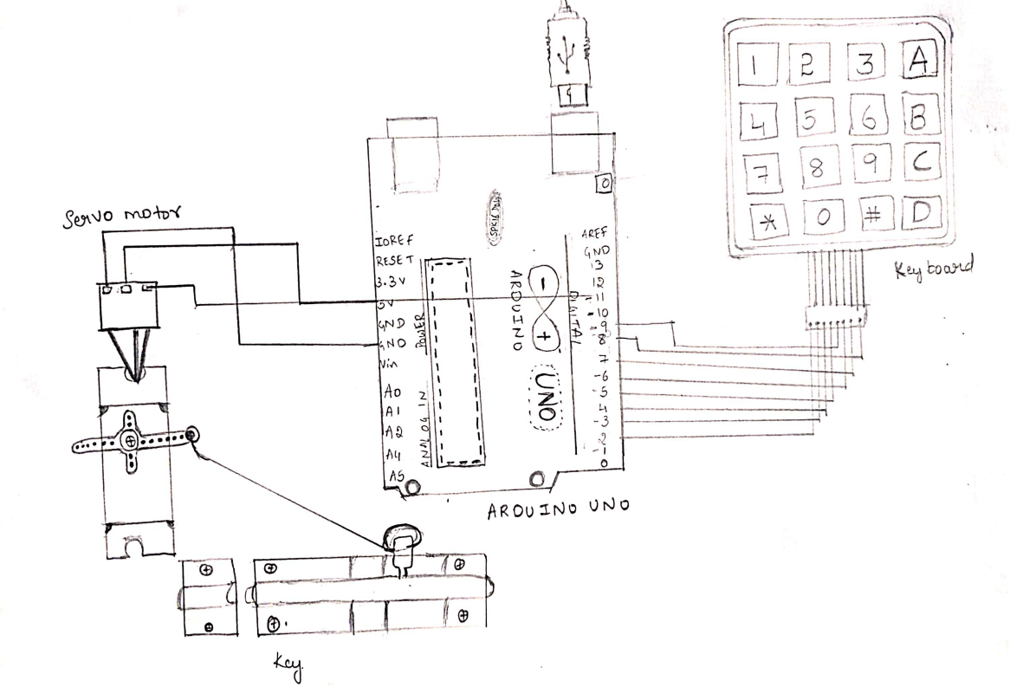

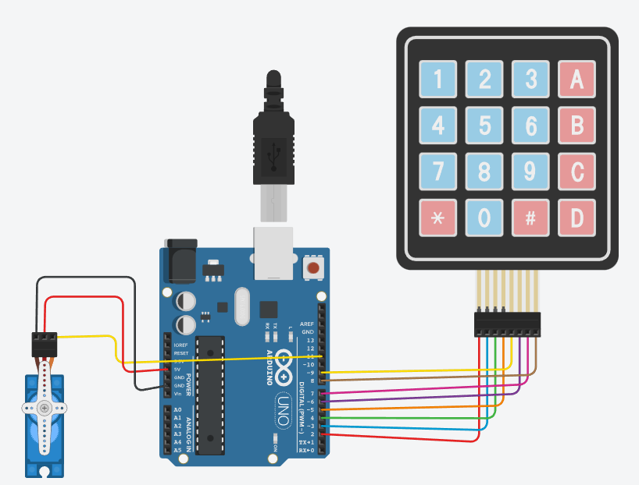

**MANUAL CONNECTIONS OF THE PROJECT**

Before execution

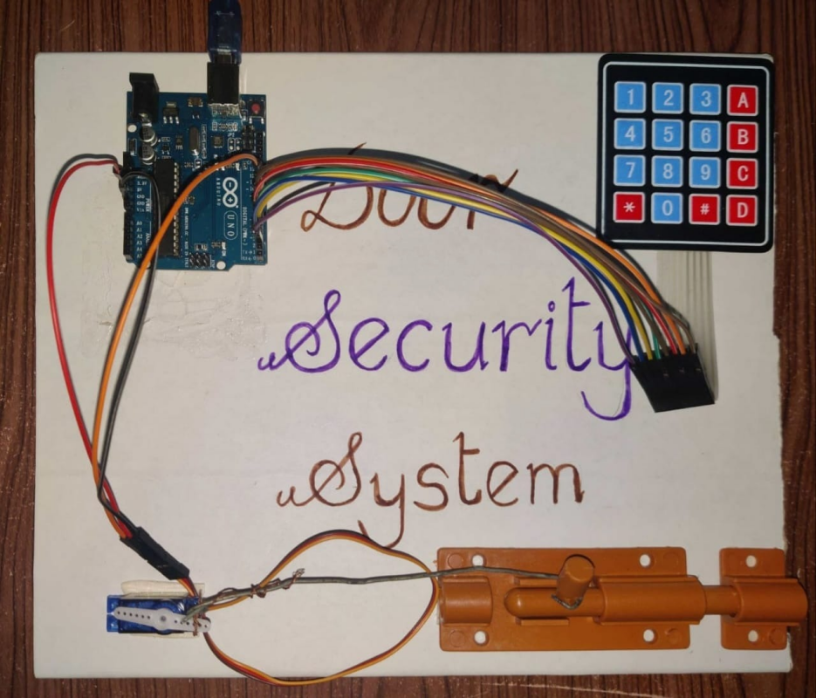

After execution

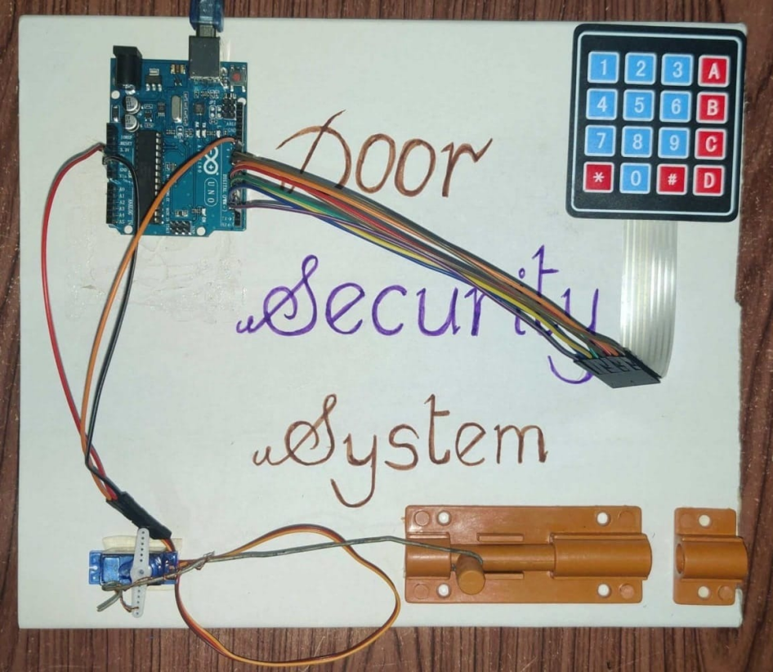

**Code**

#include <Servo.h>

#include <Keypad.h>

Servo ServoMotor;

char* password = "6666";

int position = 0;

const byte ROWS = 4;

const byte COLS = 4;

char keys[ROWS][COLS] =

{

{'1','2','3','A'},

{'4','5','6','B'},

{'7','8','9','C'},

{'*','0','#','D'}

};

byte rowPins[ROWS] = {8, 7, 6, 9};

byte colPins[COLS] = {5, 4, 3, 2};

Keypad keypad = Keypad( makeKeymap(keys), rowPins, colPins, ROWS, COLS );

void setup()

{

ServoMotor.attach(11);

LockedPosition(true);

}

void loop()

{

for(;;)

{

char key = keypad.getKey();

if (key == '*')

{

position = 0;

LockedPosition(true);

}

if (key == password[position])

{

position ++;

}

if (position == 4)

{

LockedPosition(false);

}

delay(100);

}

}

void LockedPosition(int locked)  
{  
 if (locked)  
 {  
 ServoMotor.write(11);  
 }  
 else  
 {  
 ServoMotor.write(180);  
 }  
}

**README**

1. First we are taking components that are jumper wires, keypad, Arduino UNO, servo motor, lock, USB cable, and laptop.
2. Giving Connection from Arduino UNO (9,8,7,6,5,4,3,2) to keypad (1 to 8)
3. Now from Arduino UNO (GND,5V,11) to servo motor (power, signal, ground)
4. Now servo motor to key
5. Now code is executed in Arduino UNO IDE with the help of the USB cable you connect to Arduino UNO.
6. Then it gets executed and the servo motor rotates 180 degrees, and the lock gets opened.

**CONCLUSION**

The digital code lock performed as expected. This digital code lock is very marketable because it is easy to use. Comparatively inexpensive due to low power consumption, and highly reliable.

This is most prevalent form of digital lock as it uses numerical code for authentication. The code lock is therefore particularly useful in door locks and equipment locks.